Kiln to table

E. GLASS PROJECT

E3. PATTERN / DIAGRAM (Optional)
Overwrite existing image:
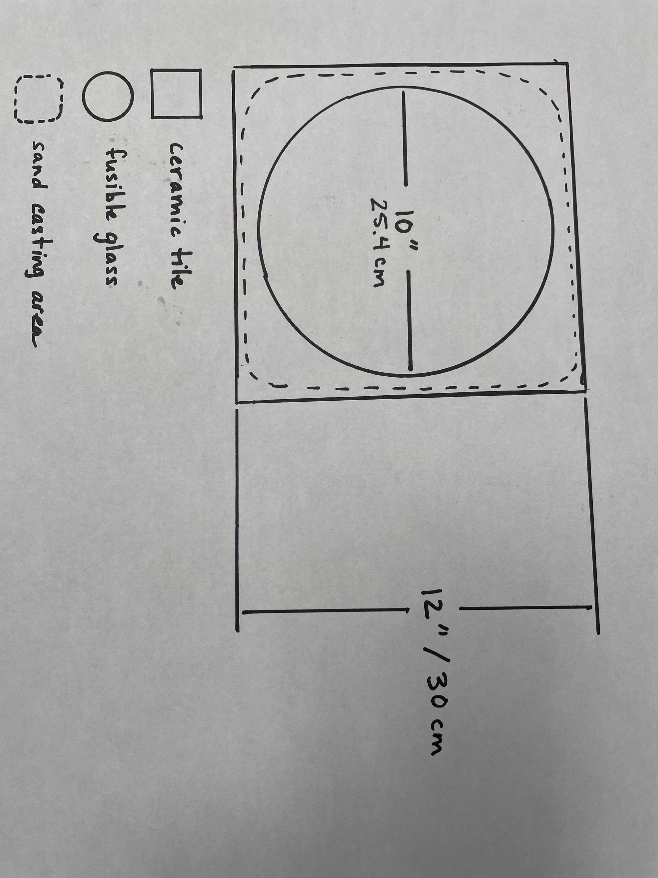

E4. GLASS PROJECT TITLE AND DIFFICULTY LEVEL
Overwrite existing text:

INSERT TITLE OF PROJECT
Creates one 10-inch diameter bowl

Select applicable
Difficulty level General | Intermediate | Advanced

E5. TOOLS AND MATERIALS (use F. TOOLS CHECKLIST)
Overwrite existing text:

Tools:
- Dust mask
- Assortment of stencils for glass powder designs
- Assortment of objects for impressing into the casting powder
- Medium and large glass powder sifters
- Small spoons
- Slumping mold prepared for firing (see notes)
- * Glass cutter, grozier breaker plier if cutting your own rounds

Materials:
- Two 10-inch diameter precut clear 96 COE round blanks or cut your own *
- Assortment 96 COE coarse and medium frit, glass powder and stringers
- Sand Casting Mix Silica-Free, 5 lb.
- 12-inch ceramic tile or ceramic kiln shelf
- Alcohol based cleaner or 50/50 water and vinegar spritz and lint free cloth
- Unscented hairspray

E6. METHOD
Overwrite existing text:
1. Cover the ceramic tile or kiln shelf with the sand casting mix, spreading it evenly over tile to create a base approximately 1-inch thick.
2. Press textured objects into casting powder leaving a pattern.
3. Place one 10-inch round blank carefully onto casting powder.
4. Using stencils, sift glass powder onto the glass, and carefully remove the stencils to leave the powder design behind.
5. Carefully place the second 10-inch round blank on top of the powdered round.
6. Decorate surface with glass frit and stringers.
7. Place project (tile/sand/glass) in kiln on 1-inch posts.
9. Program for Flow fire (see Appendix C, page 62).
10. Once flow fired, remove cast glass and clean carefully, removing any casting powder debris.
11. Apply to a prepared 10-inch round fusing mold.
12. Program for Slump fire (see Appendix C, page 64).

